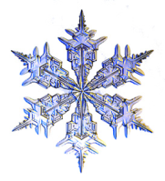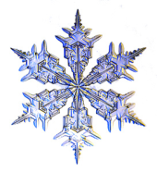
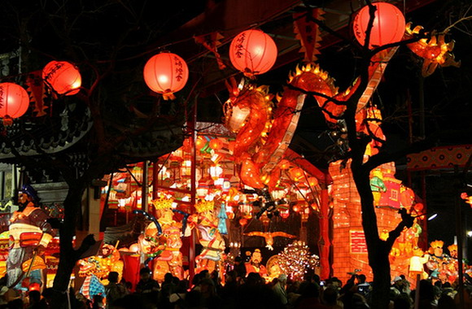
Learn about unique traditions, celebrations, and holidays that occur around the world during December and January.
Chinese New Year
Chinese New Year is the most important of the traditional Chinese holidays. It falls on different dates each year, between January 21 and February 20. Visits to friends and family take place during this celebration. The color gold is said to bring wealth, and the color red is considered especially lucky. The New Year's Eve dinner is very large and includes fish, noodles, and dumplings.
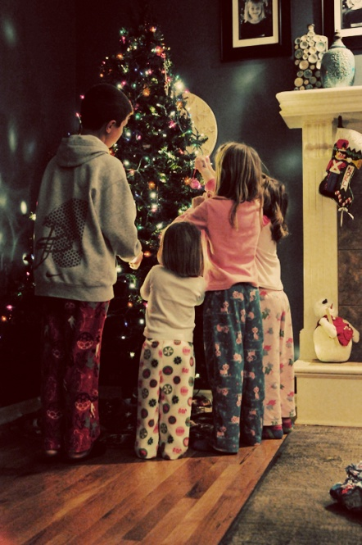
Christmas
Christmas is celebration of the birth of Jesus Christ. Christmas in the United States brings together many customs from other countries and cultures. Around the world, family members help to decorate the tree and home with bright lights, wreaths, candles, holly, mistletoe, and ornaments. On Christmas Eve, many people go to church. Also on Christmas Eve, Santa comes from the North Pole in a sleigh to deliver gifts; in Hawaii, it is said he arrives by boat; in Australia, the jolly man arrives on water skis; and In Ghana, he comes out of the jungle.

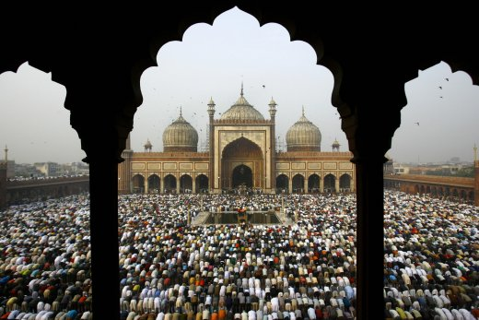
Eid Al Adha, the Festival of the Sacrifice
Eid Al Adha is celebrated by Muslims on the 10th day of the month of the lunar calendar (In 2008, it fell on December 8) to commemorate the willingness of the prophet Ibrahim (or Abraham) to sacrifice his son for God. Today, Muslims sacrifice an animal—usually a goat or a sheep—as a reminder of Ibrahim's obedience to God. The meat is shared with family, friends Muslims or non-Muslims, as well as the poor members of the community.

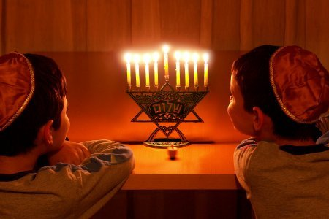
Hanukkah
Jewish people celebrate Hanukkah, a holiday honoring the Maccabees victory over King Antiochus, who forbid Jews to practice their religion. For eight nights, Hanukkah is celebrated with prayer, the lighting of the menorah, and food. A menorah has nine candles, a candle for every night, plus a helper candle. Children play games, sing songs, and exchange gifts. Potato pancakes, known as latkes in Yiddish, are traditionally associated with Hanukkah and are served with applesauce and sour cream.

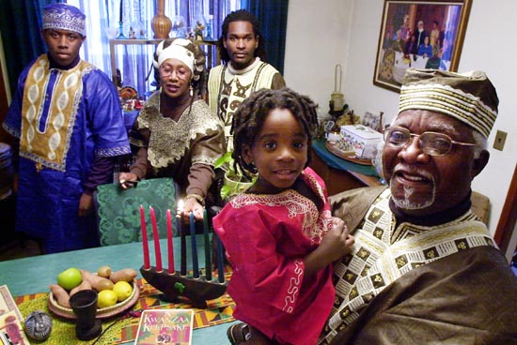
Kwanzaa
On December 26, Kwanzaa is celebrated. It is a holiday to commemorate African heritage. Kwanzaa lasts a week during which participants gather with family and friends to exchange gifts and to light a series of black, red, and green candles, which symbolize the seven basic values of African American family life that are unity, self-determination, collective work and responsibility, cooperative economics, purpose, creativity, and faith.
New Year's Day
New Year's Day is the first day of the year in the Gregorian calendar on January 1. There are often fireworks at midnight to celebrate the new year. Commonly served in the southern part of the United States, black-eyed peas are thought to bring luck and prosperity for the new year, greens (usually collards) bring wealth, and pork because pigs root forward.

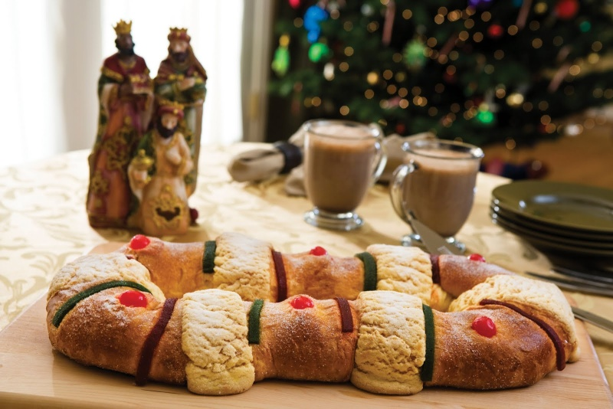
Three Kings Day
At the end of the Twelve Days of Christmas comes a day called the Epiphany, or Three Kings Day. This holiday is celebrated as the day the three wise men first saw baby Jesus and brought him gifts. On this day in Spain, many children get their Christmas presents. In Puerto Rico, before children go to sleep on January 5, they leave a box with hay under their beds so the kings will leave good presents. In France, a delicious King cake is baked. Bakers will hide a coin, jewel or little toy inside it.

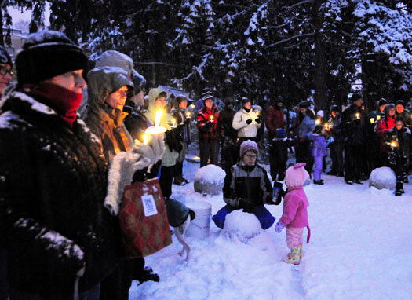
Winter Solstice
The Winter Solstice occurs around December 21st. It is the shortest day of the year. People all over the world participate in festivals and celebrations. Long ago, people celebrated by lighting bonfires and candles to coax back the sun.

Text adapted from Celebrate Chinese New Year with Fireworks, Dragons, and Lanterns by Carolyn Otto, 2009, National Geographic Society
Text adapted from Celebrate Christmas with Carols, Presents, and Peace by Deborah Heiligman, 2007, National Geographic Society
Text adapted from Celebrate Hanukkah with Light, Latkes, and Dreidels by Deborah Heiligman, 2008, National Geographic Society
Text adapted from Celebrate Kwanzaa with Candles, Community, and Fruits of the Harvest by Carolyn, 2008, National Geographic Society
Works Cited
"Winter Celebrations." National Geographic Kids. National Geographic. Web. 5 Dec. 2011. <http://kids.nationalgeographic.com/stories/peopleplaces/winter-celebrations/>.

